17.Write a Python Program to a db with name dob
Aim
To create a database named dob using Python and SQLite.

Algorithm
- Import the sqlite3 module.
- Connect to the database named dob.db.
- Create a cursor object.
- Execute an SQL query to create a table.
- Commit the changes.
- Close the database connection.

Python Program
import sqlite3
# Create database
conn = sqlite3.connect("dob.db")
cursor = conn.cursor()
# Create table
cursor.execute("""
CREATE TABLE IF NOT EXISTS student(
id INTEGER PRIMARY KEY,
name TEXT,
age INTEGER
)
""")
print("Database 'dob.db' created successfully.")
conn.commit()
conn.close()

Sample Input
No input required.
Sample Output
Database 'dob.db' created successfully.
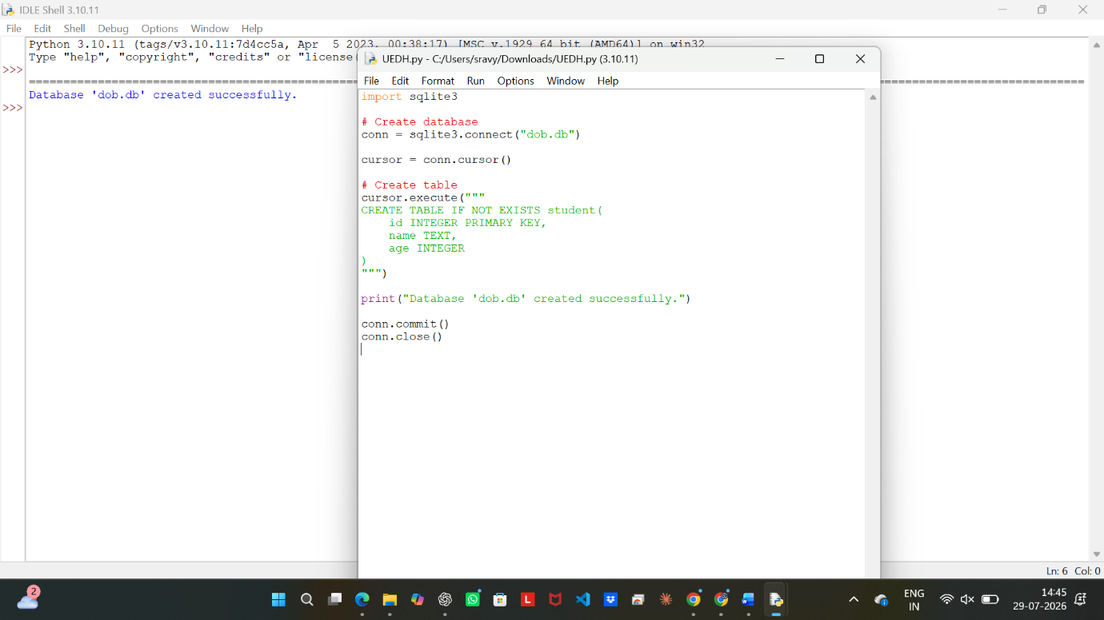

Result
Thus, the SQLite database named dob.db was created successfully.

